**What sort of industry do these companies belong to? Highlight their special characteristics.**

The mining industry is best described as an oligopoly. Oligopolies are characterized by a high degree of interdependence between firms because a small number of firms accounts for the majority of total sales in the market. Actions that one mining firm takes, for example Glencore’s strategy of pursuing potential mergers and acquisitions or the decision to raise shareholder dividends amid increasing commodity prices, are likely to lead to responses by competitors. The article confirms as much, stating that “Rio Tinto may not lag far behind Glencore. S&P upgraded the miner Tuesday, partly due to its potential for M&A”. This suggests interdependence between firms in the mining sector. Further evidence of the oligopolistic nature of the mining industry comes in the form of their ability to exhibit some form of price leadership. Says David Neuhauser of Livermore Partners: “’I’m supportive of their current M&A strategy,’ said Neuhauser. ‘They are focus not just on getting scale but on substance. Once they get scale, they can have a say on price.’” This highlights the impact of price leadership in the mining market.

Another important characteristic of firms in extractive industries is that they face significant barriers to entry. The fixed-capital-intensive nature of mining makes it difficult for new firms to enter the market. What’s more, regulatory climates and ecological concerns constrain the number of potential mining sites, further limiting the ability of new entrants to gain a foothold in the market.

**Is rivalry natural in this industry? Why? What sort of strategic forces interplay in this market? What can we learn from Porter’s strategic model with respect to this particular industry?**

Some characteristics of the mining sector intensify rivalries, while a few others diminish rivalries. Supply constraints increases rivalry between firms; as the article notes, “long term, miners must invest to replace the commodities they mine out, or face declining production”. The lack of product differentiation and relatively low switching costs for consumers in commodity markets also increase rivalry, as it is fairly easy for consumers to take their business elsewhere because goods are fairly homogenous. What’s more, high cost fixity (that is, the proportion of total costs represented by fixed costs) among mining firms can lead to larger margins and greater competition for marginal business, as each additional unit sold has a larger marginal impact in covering large fixed costs.

These high fixed costs also lead to larger barriers to exit, which increases rivalry because firms would be unable to recoup the costs it sinks into extracting and processing raw materials. Demand growth can also impact the intensity of rivalries in the mining industry. For example, when global commodity demand increases, as it is for some commodities currently, firms are content with current business levels. Demand for commodities required for computing technology (e.g., nickel, cobalt, etc.) will retain strong demand and therefore reduce intense rivalries. Similarly, high market concentration reduces the intensity of rivalries in the mining sector because there are few larger firms jockeying for business. However, if global demand decreases for a given commodity, it can sharpen rivalries as firms view the decline as a potential threat to their ongoing operation.

Porter’s strategic framework tells us much about the nature of the mining sector. The fact that commodities are fairly homogenous creates a significant threat of substitutes. This is one way in which the mining sector may be more competitive than other oligopolies. However, as we noted, there are significant barriers to entry in terms of high fixed costs and access to distribution channels. As we noted, there are also regulatory and policy challenges to navigate in extractive industries. Another factor that increases competition in the mining sector relates to buyer power. Buyers tend to buy commodities in large quantities, which gives them power in that taking their business elsewhere can have an outsized impact on a single firm, especially if, as we noted in the mining sector, there is high cost fixity in the market. On the other hand, suppliers hold some power, too, that affects sustained profitability. For example, the relatively small number of suppliers, as well as a limited supply of raw materials, give some advantages to suppliers.

**Who is a bigger player? How do you know?**

BHP Billiton is the biggest player in the market based on their free cash flows and their cash and short term investments depicted in the table in the article. Glencore, as a relatively smaller firm in terms of cash and short term investments, may be looking to gain a competitive advantage by pursuing high-margin firms it can acquire or with which it can merge.

**What is happening globally in terms of prices and overall demand for these companies’ core products, particularly iron ore? Forecast prices for iron ore (one of the main commodities these companies produce/sell/trade) for the next ten years.**

Commodity prices largely increased during the Great Recession but have since stabilized or declined. Though there is some variation, the graphs in the appendix illustrate that the price of copper, iron ore, nickel and zinc followed this pattern. Prices of gold have largely increased over the past 50 years, though they have remained flat for the last five years. The price of aluminum has risen and fallen but remains largely similar to where it was in 1980.

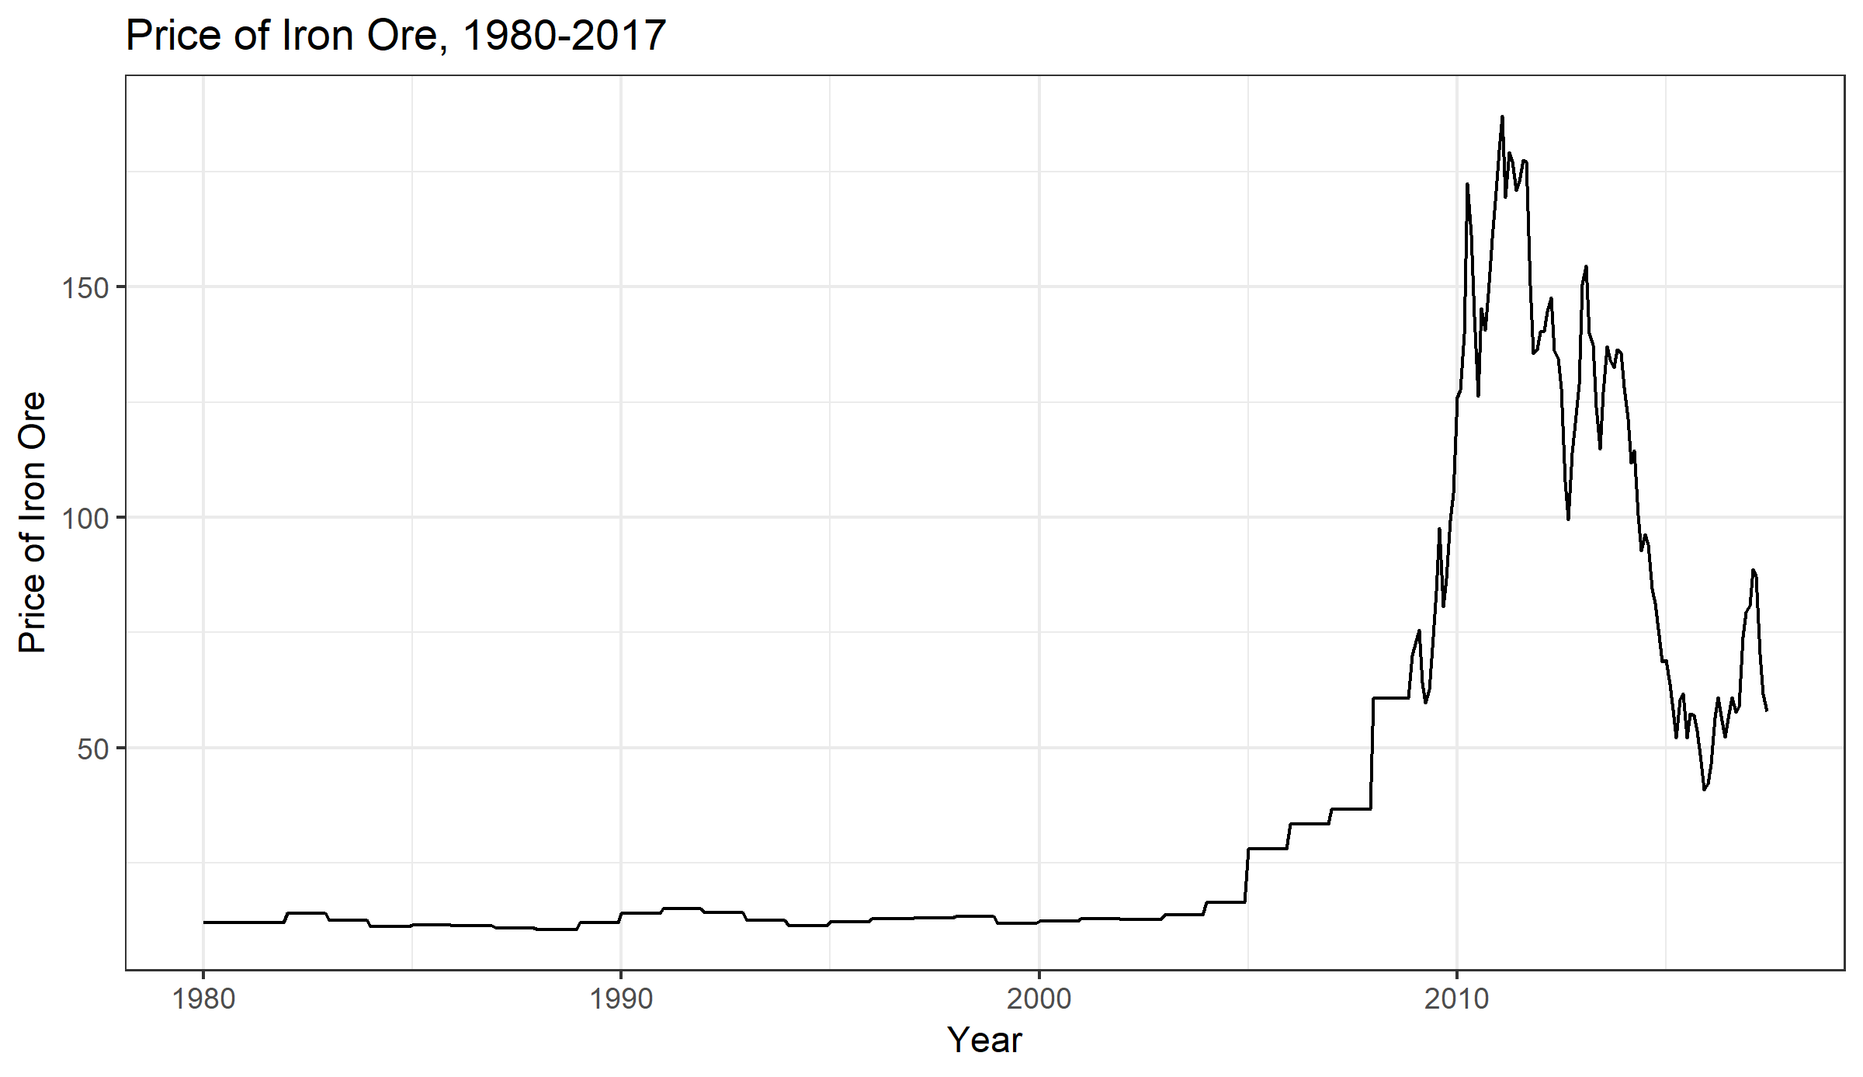

An ARIMA(1,1,1) model best fit the data. You can see that the residuals are evenly distributed around 0, but they vary significantly as variance spikes between 2008 and 2018.

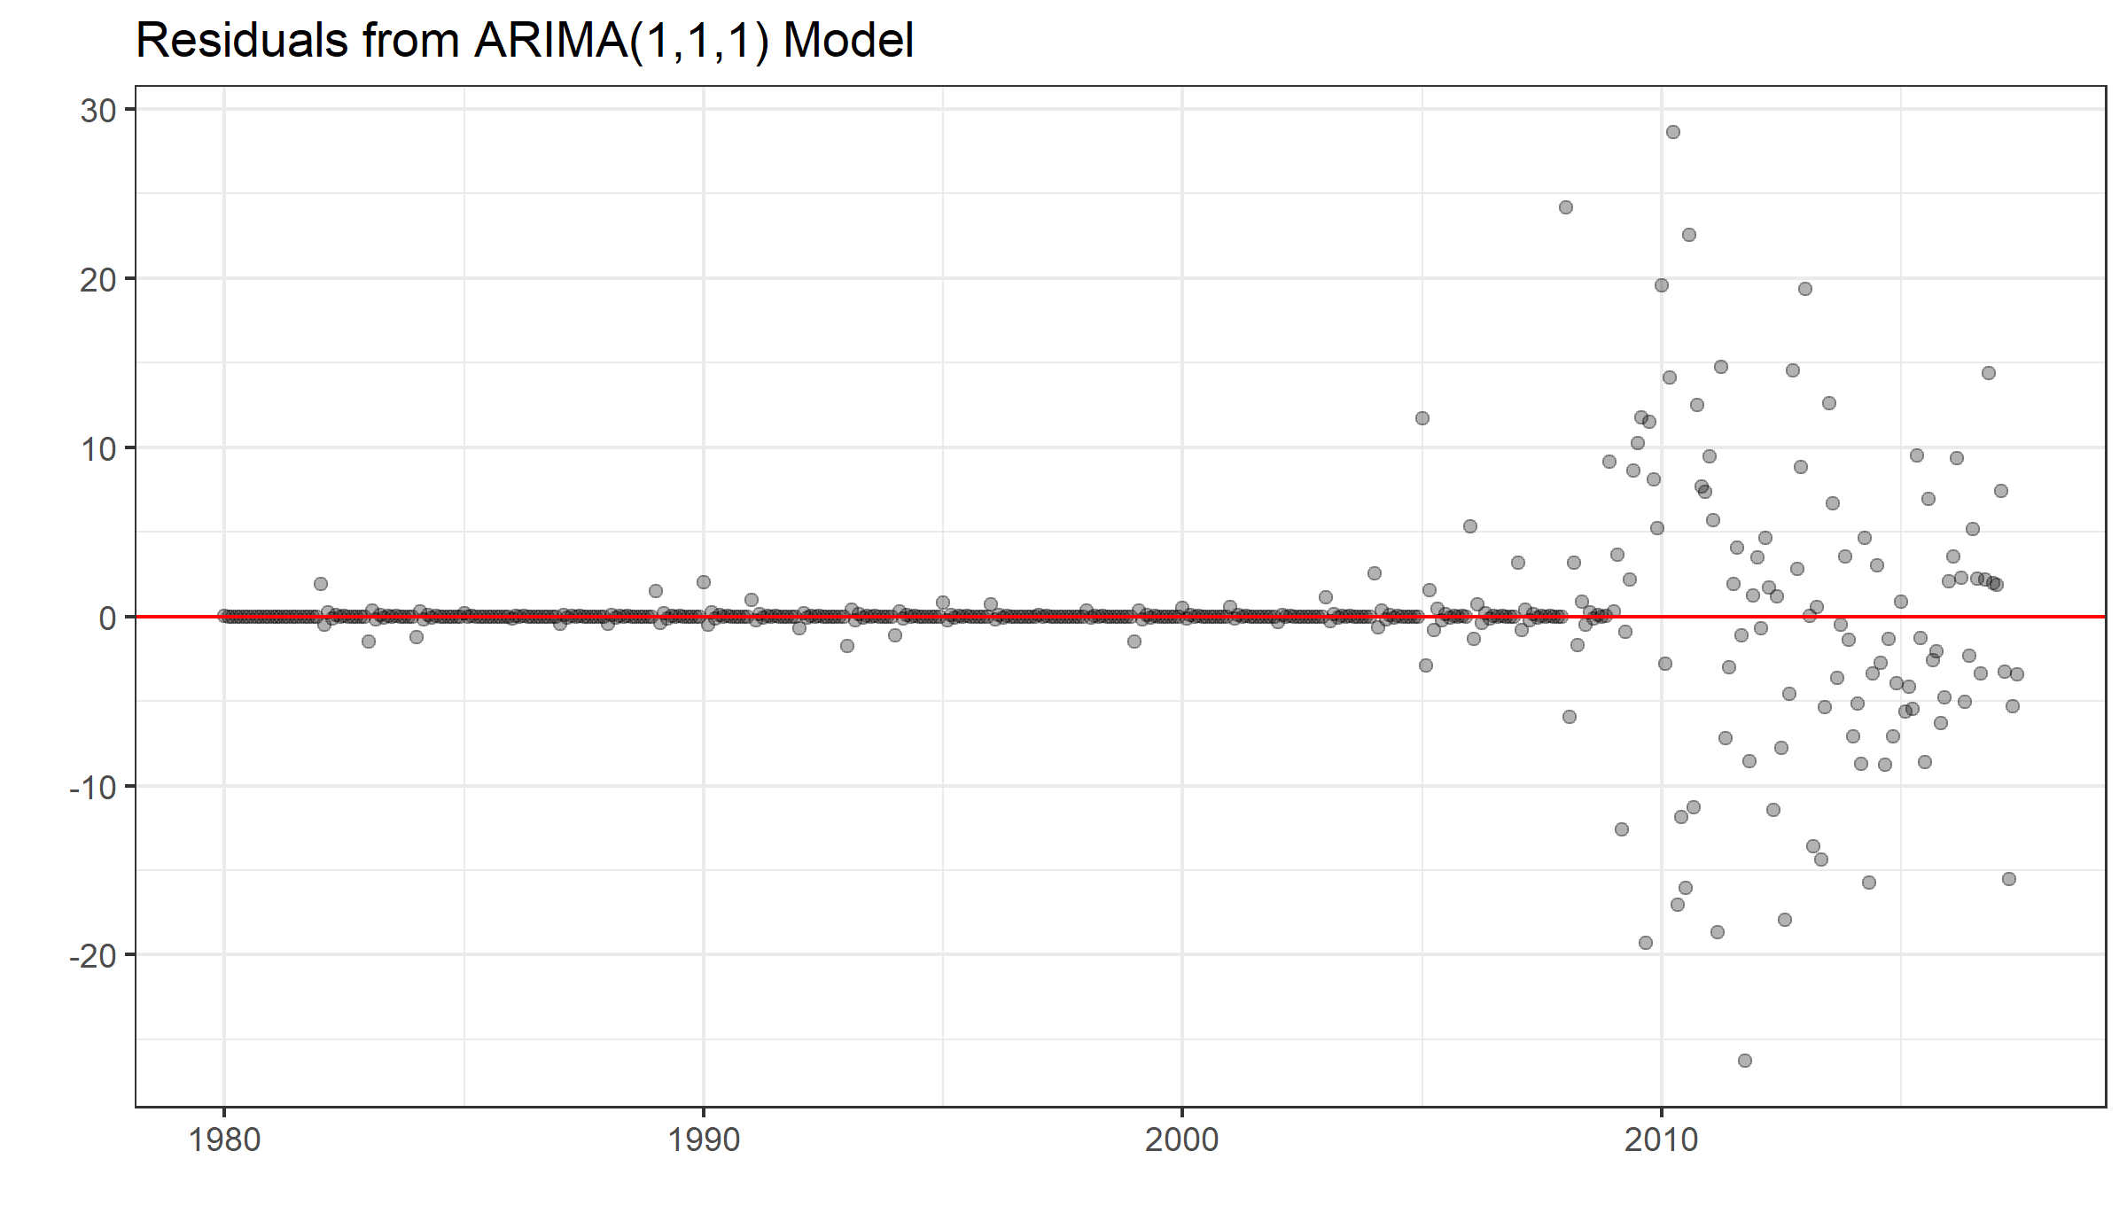

This model suggests that iron ore prices will stabilize around $50 per metric ton over the next ten years.

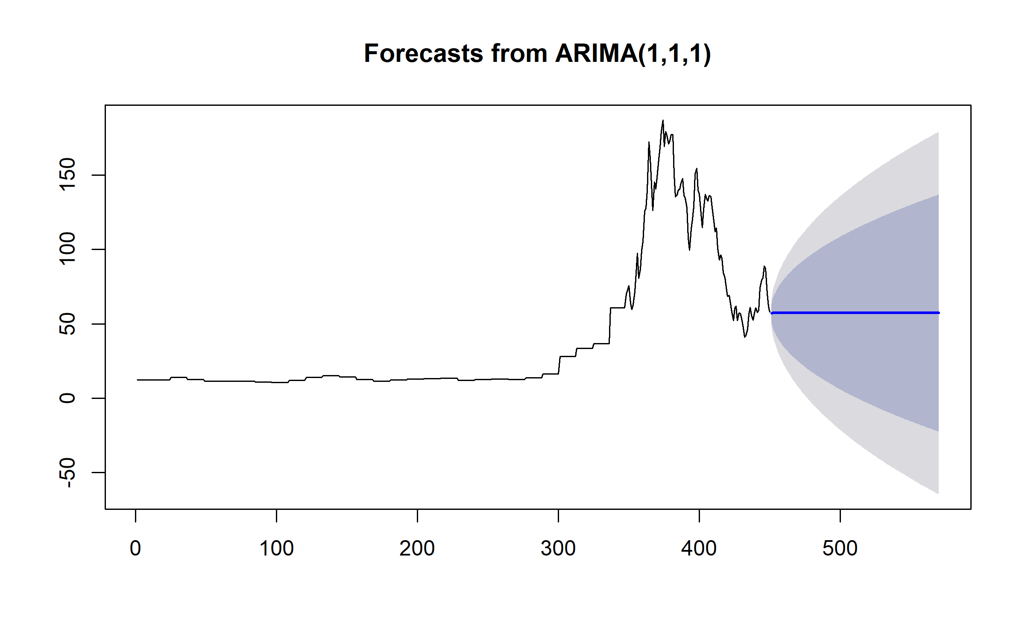

**These are publicly traded companies. What is happening to their stock prices and earnings?**

Between 2012 and 2019, the “Big 4” mining stock prices remained relatively stable. All four firms experienced a decrease in their stock prices around the start of 2016. While Rio Tinto has recovered all of its losses and returned to its share price as of January 2012, both Glencore and Vale have struggled to regain their prior valuations. BHP Billiton’s share price lost nearly two-thirds of its value before rebounding in 2019 back to roughly $50 per share.

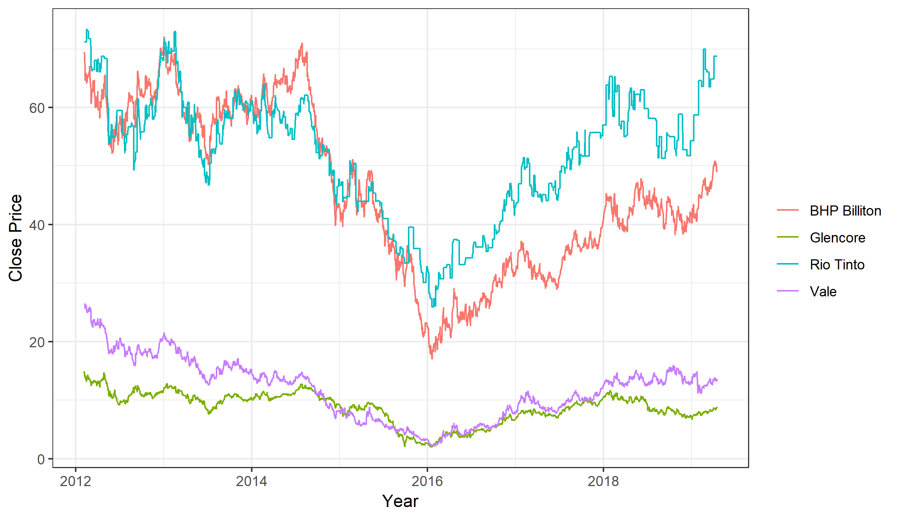

**Is merger and acquisition obvious? If so, who will merge with whom and why?**

Among the “Big 4” mining companies, no M&A seems particularly obvious. However, there are two mergers that could prove advantageous. First, Vale and Glencore could merge to increase their market capitalization to threaten the preeminence of BHP Billiton and Rio Tinto. Furthermore, Rio Tinto is in the strongest position of all to acquire one of its smaller competitors, as its share price has rebounded to 2012 levels while others have continued to lag behind.

**Appendix**

